**Web Browser Application**

**A REPORT**

***Submitted by***

**Beni Iyaka**

***In fulfillment of requirement***

***Of***

**Bachelor of Science (BSc.)**

**IN**

**COMPUTER SCIENCE**

**MACS**

**HERIOT WATT UNIVERSITY**

**F20SC**

**OCTOBER 2015**

Table of Contents

1. Introduction...................................................................................................................3

2. User guide…………………………..................................................................................8

3. Developer guide ............................................................................................................16

4. Testing…………...…………………………………............................................................22

5 Summary…………….…..................................................................................................26

6. Bibliography.. ................................................................................................................28

1. **Introduction**

A web browser is an application used for retrieving, presenting and traversing uniform resources identifies (URL) on the World Wide Web.

Web browser is used in all kind of devices in many different ways with all sorts of features and with all sorts of versions.

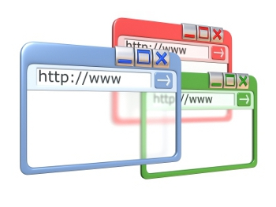

Figure1 (Web browser)

* **Purpose**

The purpose of this report is to give an overview of the task I was given to create a web browser using C# language 2012 version.

* **Scope**

The product is have created is a web browser application which consist of a menu bar, Buttons, Panels, Tab controls, Tool strip bars, etc.

* **Methodology**

I used the object oriented approach to design the web browser. I drew out some diagrams such as class diagrams, collaboration diagrams, activity diagrams and sequence diagrams so as I could have a better understanding and idea of what’s required from the application. The tools I used to develop this application was Microsoft Visual Studio 2012 and Xml file to store data.

* **Assessment criteria used**

While developing the application, Mrs. S. Kumar had given us some suggestions and explanations on how we could successfully complete the coursework.

* 1. **Requirements’ checklist**

**Purpose**

The purpose of this document is to outline the requirements that were given to me and to also show if those requirement were successfully accomplished or not. Below is the table showing requirements that were given and next to each, there will be ticks to show if they were successfully accomplished or not.

|  |  |  |
| --- | --- | --- |
| **Requirements** | **Success** | **Fail** |
| 1. Make a web browser. |  |  |
| 1. Allow the user to input URL. |  |  |
| 1. Send HTTP request. |  |  |
| 1. Display contents message on the interface. |  |  |
| 1. The message should be a raw html file. |  |  |
| 1. 200 (OK) HTTP responses. |  |  |
| 1. HTTP response status error. |  |  |
| 1. 400 Bad request. |  |  |
| 1. 403 Forbidden. |  |  |
| 1. 404 Not found. |  |  |
| 1. User should create homepage. |  |  |
| 1. User should edit homepage. |  |  |
| 1. Load URL homepage on homepage startup. |  |  |
| 1. Add URL as favorites |  |  |
| 1. User should be able to name each favorite. |  |  |
| 1. User should be able to edit favorite. |  |  |
| 1. User should be able to delete favorite. |  |  |
| 1. Program should load favorite on click. |  |  |
| 1. Save history. |  |  |
| 1. History list should be loaded on browser startup. |  |  |
| 1. Navigate Previous and next page. |  |  |
| 1. Jump a page by clicking on the history link. |  |  |
| 1. Multi-threading. |  |  |
| 1. Use menu buttons. |  |  |
| 1. Use shortcut keys |  |  |
| 1. Don not use the C# webBrowser class |  |  |

* 1. **Design Consideration**

Most applications are customized to be suitable and introduce with the person using the application. In applications such as web browsers, Design consideration is more important because it helps the user to be more comfortable with the application and also design in a way to be straight forward.

In order for me to achieve those aspects while designing the application, I kept in mind different design considerations aspects which are:

* **Easy Navigation**

This is one of the top issues that users have while using applications. This means that when they are using the application, they get stuck because they get trouble finding the content thy need or looking for.(Jennings, 2008).

Looking at my application, I tried my best to avoid the problem by focusing more on usability by having shortcuts around the form and on every there are buttons with words on them telling their functions.

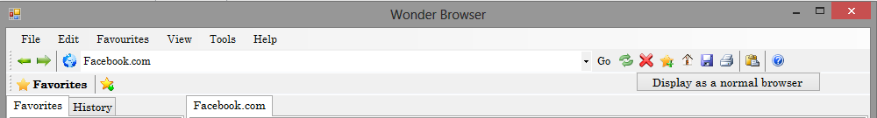

**Figure 1**

* **Relevant content**

This is one of the top issues that users have while using the application because they get to find irrelevant content in the application which becomes frustrating and time consuming. (Rodriguez, 2008)

In my application, I tried my best to avoid the problem by implementing content that are more relevant with the program by making the use of menu bar, buttons and other tools.

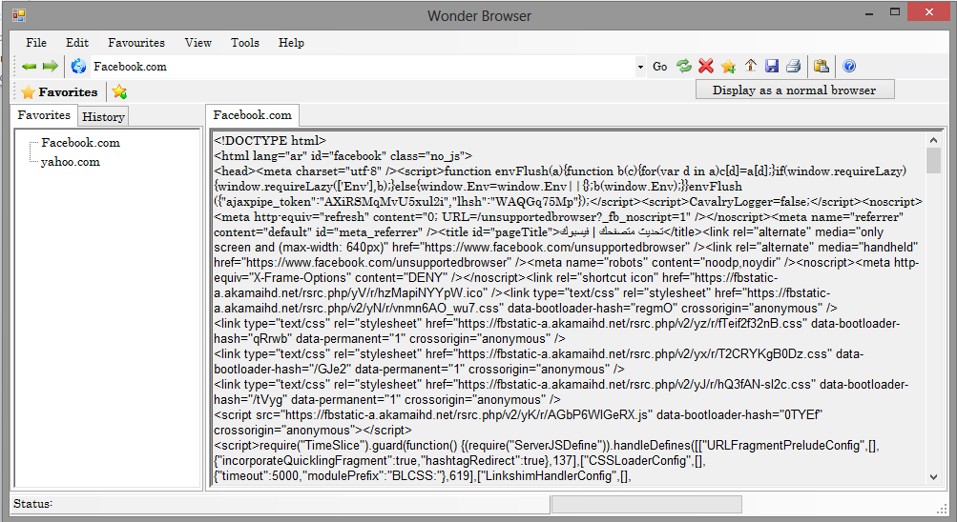**Figure 2**

* **Fully-Functional application**

This is one of the top issue that users have while using an application because developers publish an application that doesn’t work properly meaning have some buttons that aren’t coded or doing what it was supposed to be doing.

In my application, I tried avoiding that making sure that all the controls in application are well coded and doing what they were supposed to do.



Figure 3

* **Error handling**

This is one of the top issues that users have while using an application because developers make an application that doesn’t handle errors. Which means the user isn’t aware of what they are doing wrong. This may result to the system crashing or not working properly.

In my application, I tried avoiding that by drafting proper messages to warn the user while doing something wrong.

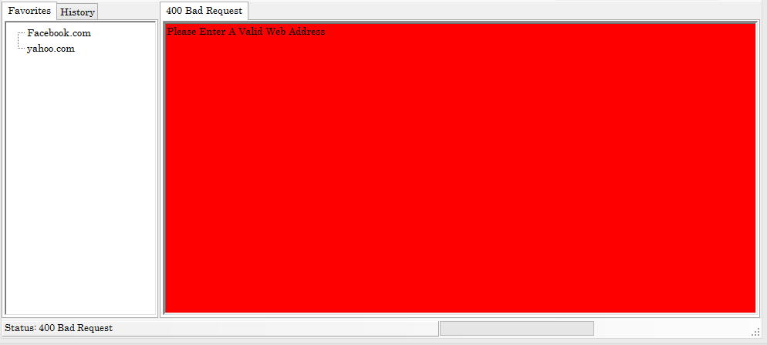Figure 4

1. **User guide**
   1. **General Information**

General information section explains the terms in general and the intended purpose of the application.

**System Overview**

Web browser application is an application that allows the user to input a URL of their choice and then display a feedback of the URL in a html format. The application provides a variety version of controls used in gathering the user URL. The application saves the URL into an XML file.

**Organization of the Manual**

The user guide consists of five sections: General information of the application, Application summary, Getting started, using the application and Help.

General information section explains the application in general and the purpose of which it is intended.

Application summary section gives a broad overview of the application. The summary elaborates the use of the application’s hardware and software requirements, system configuration, users’ computer literacy and application’s behavior in case of contingencies.

Getting started section elaborates on the installation of the application on the computer. This section presents the system menu in brief.

Using the application provides a broad explanation of the application functions.

Help section describes in what way the user may get help if in need of any.

**Application Summary**

Application summary gives a general overview of the application. The summary elaborates on the use of the application hardware and software requirements, application’s configuration, and user computer literacy and application’s help in case of any problem.

**Application Configuration**

This web browser application operates on computers with a windows operating system. It is also compatible with windows 93 and high versions. This application requires internet connection in order for it to work properly. After installing the application, the web browser application can be used without any further configuration.

**User Computer Literacy**

The user doesn’t require a certain qualification to use the application. The application can be used by anyone who knows how to use the internet.

**Application’s help**

In case of any help concerning the application, the user can click on the help button and send me an email so that I should know what kind of problem they are facing.

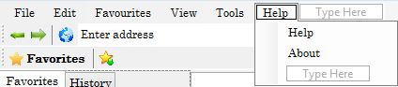

Figure 1

* 1. **GETTING STARTED**

This section explains how to install the application on the computer. The section explains briefly the application menu.

**Installation**

The web browser application version can be installed after clicking the .exe file and follow the instructions.

**Application Menu**

The web browser application consists of a menu bar which has six items that will be useful to the user. The Menu tool displays the items such as newtab, new window, close tab, open, save, page setup, print, print preview, send and exit. The Edit tool contains items such as set current page and type new home page. The favorites tool displays the items such as add favorites and links. The view tool displays items such as toolbars, history, refresh, source, full screen and splash screen. Tools displays delete browser history, options, calculator, calendar, solitaire. The help tool displays the help and about the application.



**Figure2. Menu bar of the**

**Web browser application**

**File menu**

The file menu (Figure 3) consists of **New Tab** which allows the user to open a new tab with a button click; **New Window** which allows the user to open a new web browser; **Open** which allows the user to open a saved URL; **Save** which allows the user to save a page of their page of their choice. **Page Setup** which allows the user to customize the page that their using. **Print** allows the user to print the page that they are on. **Print preview** allows the user to preview their page before printing it. **Send** this allows the user to send the current page link via email. **Exit** allows the user to close the application.

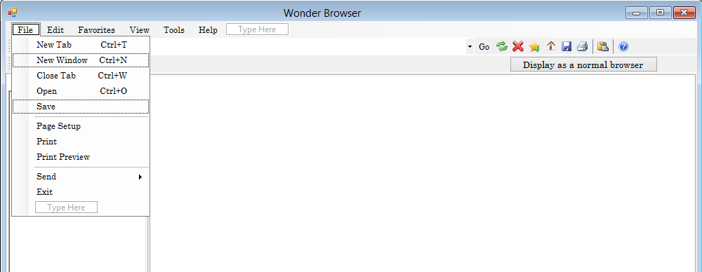

Figure3. Menu bar

**Edit menu**

The edit menu (Figure 4) consists of two sub menus which are **set current page** and **Type new home page**. The set current page allows the user to set the current page that they are surfing as their hope page. The type new home page is a textbox which allows the user to input a URL of their choice.

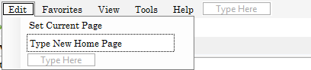

Figure4. Edit menu

**Favorites menu**

The favorites menu (figure 5) consists of two sub menus which are add favorite and links. The click to add button allows the user to click and add a URL to their favorite list which will be displayed below the links label.

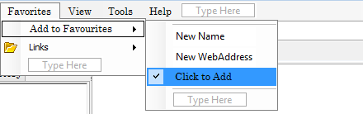

**Figure5. Favorites menu**

**View menu**

The view menu (figure 6) consists of six sub menus which are **Toolbars** this has two sub menus that hide and display on button click respectively. **History** this displays all the history URL as they are processed. **Refresh** this refreshes the application. Source this displays the URL in notepad with it location in the history file. **Full screen** this changes the view of the application to a full view. **Splash screen** this docks the screen resolution.

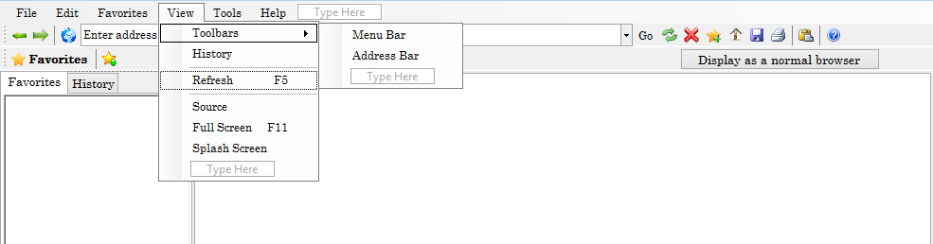

**Figure6. View menu**

**Tools menu**

The tools menu (Figure7) consists of five sub menu which are: **Delete Browser History** this allows the user to clear the history file. **Options** this allows the user to customize the web browser to suite their preferences. **Calculator** this allows the user to open a calculator. **Calendar** this allows the user to open a calendar. **Solitaire** this allows the user to open the solitaire game.

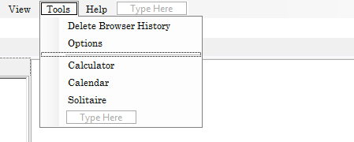

**Figure7 Tools menu**

**Help menu**

The help menu (Figure 8) consists of two sub menu which are: **Help** this allows the user to email the developer to report or ask for something regarding the application. **About** (figure 9) this allows the user to view the application descriptions.

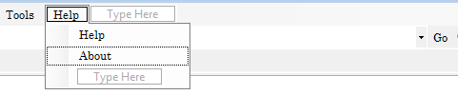

**Figure 8 Help menu**



**Figure9. About form**

**Using the application**

This section provides detailed description of the application functions.

 This is the back button which allows the user to access the previous page.

 This is the forward button which allows the user to access the next page.



The picture above represents the drobox where the user inputs the URL and click on the go button to send http request.



The following are shortcuts which help the save time when wanting to perform a certain task. At the left hand side is the go button which helps the user sends an http request. The refresh button. The delete button which helps delete all the history. Then add favorite shortcuts which allow the user to add a certain URL to their favorite folder.

 This is the panel where the output is displayed and the other panels this displays the history and favorites URL of the user. The **display as a normal browser button** changes the output from an html strings to a normal webpage.

1. **Developer’s guide**

**Purpose**

The purpose of the developer’s guide is to give a complete overview of the application by using different architecture views to show different aspects of the web browser application.

**Scope**

The application applies to the overall design of the application. It contains information about the architectural design of the application and the xml structure.

**Overview**

The document provides the reader with a much deeper understanding of the design of the Web Browser application. The guide is organized into several views of the application which are the logical view, deployment views, implementation view and the data view. Of which, the **Logical view** will give an overview of the subsystems and components of the application. The **Deployment view** explains how the application will be deployed and what it will be doing. The **Implementation view** elaborates on how the application will be implemented and its network as well as it architectural setup. The **Data view** will show how the xml is structure and organized.

# Architectural Representation

This web browser application was designed using a standard three tiered architecture, with a Presentation Tier, Application Tier and Data tier. The Presentation Tier contains the entire visible application interface and handles all input from and output to the user. The Application Tier handles all of the Business logic and provides an abstraction to the xml file, the Data tier consists of the xml file and stored procedures contained within, and this provides the persistence required for the application.

Architectural Goals and Constraints

This application goal is to provide users with an effective way to subscript to the web and view the web programs.

**Logical view**

This is the layer between the user and the browser engine

Output HTML format

Display Backend

XML

Networking

Rendering engine

Browser engine

User Interface

Provide the drawing and window primitives and a set of user interface widgets.

Generates an output in the HTML format and send sit to the user interface.

This saves the given URL to the appropriate XML file.

This implements different protocols such as HTTP and FTP

This calculates the exact page layout and uses different algorithms to adjust positions of element on the page.

This loads the given URL and handles different browsing actions

Application Layer

The Application Layer provides the application logic and connects the Presentation Layer to the Database. The Application Layer is contained within the Web Services package. All communication with the Presentation layer is done through Web Services.

#### Web Services

This Package contains all of the Web Services that are provided by the application layer and consumed by the presentation layer

#### Data Access Objects (DAO)

This Package contains all of the objects which are used to communicate with the database. Each object contained in this package has a table or tables representing it in the database.

### Data Layer

The Data Layer consists of the XML file and the stored procedures contained within.

### Presentation Layer

The Presentation Layer is composed of two basic packages, user interface and the browser subsystems.

#### Browser Subsystems

##### Interface system

This subsystem is responsible for displaying components on the form and handling any actions that may be inputted.

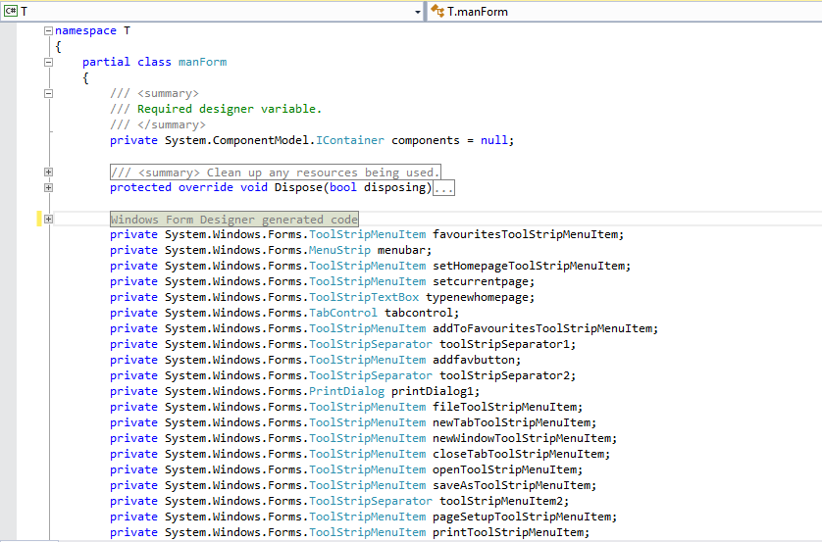

##### HTTP system

This subsystem is responsible for converting the user input and sending it the request URL to other system.

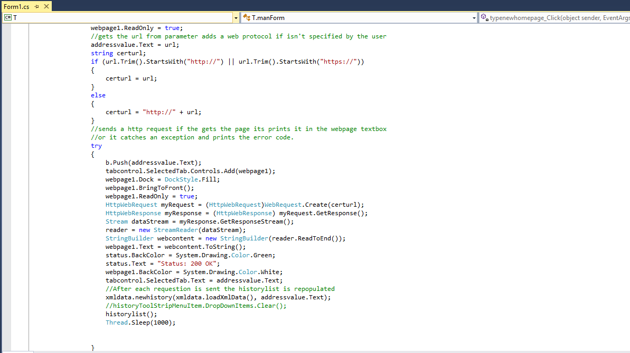

##### Error handling System

This subsystem is responsible for managing the web browser’s errors and other fault

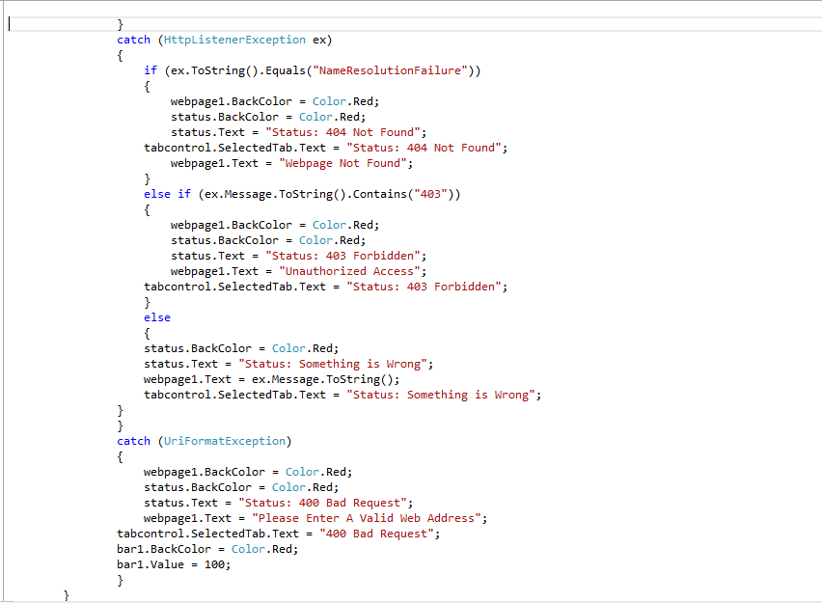

Data View

### Data Layer

The Data Layer consists of a XML file. It provides logic that is directly related to the manipulation of data through the means of stored procedures. It is this layer that will communicate with the Web Services Layer through responding to certain queries.

This diagram shows the XML of the Web browser system.

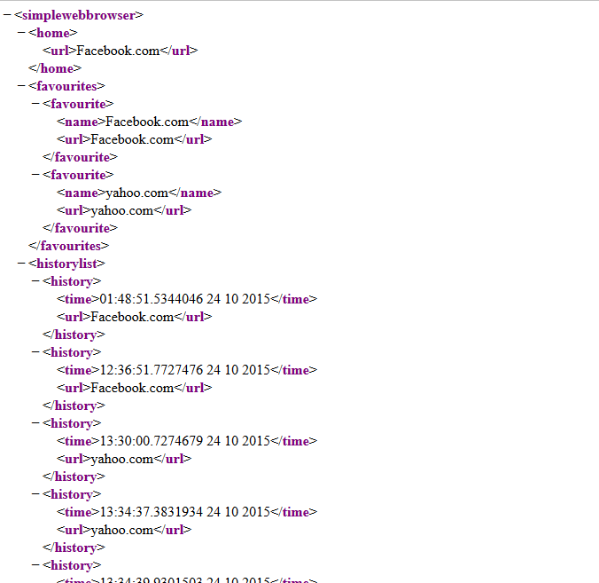

Size and performance

The application is designed to accommodate a large number of URLs and keep up with all user inputs and commands without affecting the application’s performance in any way.

1. **Testing**

| **Application Testing Checklist** | | | | | | |
| --- | --- | --- | --- | --- | --- | --- |
| Tested By | Beni Iyaka | | | | Date |  |
| Application Name | Web browser application | | | | | |
| Procedure | | Expected Result | Pass/Fail  (P/F) | Actual Results/Comments | | |
| Application Functionality | | | | | | |
| Performs primary functionality and maintains stability | | Yes | P | Opens and allows user to input URL without program errors. | | |
| Windows Fundamentals | | | | | | |
| Completes a full installation | | Yes | P | Full installation completes with no errors | | |
| Completes a local installation when you use Add or Remove Programs | | Yes | P | Program can be added or removed from the Add or Remove Programs applet under the administrator or power user account | | |
| Lists on Start menu and has desktop shortcuts for all users | | Yes | P | Is listed on Start menu and installs shortcut on desktop | | |
| Basic Application Testing | |  |  |  | | |
| Performs as expected when other applications are open | | Yes | P | No errors or hangs when multiple applications are running | | |
| Starts from the Start menu | | Yes | P | Opens correctly from the Start menu and functions with no errors | | |
| Starts from a shortcut | | Yes | P | Opens properly from the desktop shortcut and functions with no errors | | |
| Starts when another instance of the application is already running | | No | P | Allows only one instance of the program to run at one time | | |
| All shortcuts on the Start menu work correctly | | Yes | P | All shortcuts work as intended | | |
| Handles copying functions correctly | | NA | NA | NA | | |
| Works correctly with Windows display themes | | NA | P | Application functions correctly at either screen resolution | | |
| Opens Help when needed. | | Yes | P | User sends the developer an email. | | |
| Print System Testing | |  | NA | NA | | |
| Prints to printers with a long name | | Yes |  | NA | | |
| Prints to printers when you use a UNC path | | Yes | P | NA | | |
| Prints to a local printer | | NA | P | NA | | |
| Prints to a network printer | | Yes | P | NA | | |
| Prints to a PostScript printer | | NA | P |  | | |
| Prints to a file on a generic text printer | | NA | NA | Prints all documents as intended | | |
| Prints to a file on a color inkjet printer | | NA | NA | Prints all documents as intended | | |
| Prints from an LPT port other than LPT1 or LPT2 | | NA | NA | NA | | |
| Handles a print command when the printer is turned off while printing | | Yes | P | Prints to all network printers | | |
| Prints in both portrait and landscape orientation | | Yes | P | NA | | |
| Uninstallation Testing | |  | P | NA | | |
| Is removed from Add or Remove Programs | | Yes |  | NA | | |
| Removes all shortcuts from the Start menu | | Yes | P | NA | | |
| Removes all files from the installation directory | | Yes | P | NA | | |
| Does not remove system  files or shared components | | Yes | P | Wakes from standby without loss of data | | |
| Removes all application-specific Registry entries | | Yes | P |  | | |

1. **Summary**

**WHAT IS A REPORT SUMMARY?**

The report summary describes how I monitored, evaluated and handled my coursework. It presents the findings, conclusions, and recommendations from a particular evaluation, including recommendations for how evaluation results can be used to guide program improvement and decision making. The summary report describes the focus on the process of implementation the system and impact it will have after the implementation has taken place, since this would be minimal after such a short time, accessing in particular the participatory approaches used to identify the application beneficiary’s role in implementing and monitoring the application. The summary purpose was to also focus on the web browser application by analyzing the problems and issues faced during the development of the application and progress of the system through the whole entire design of the application as well as evaluating if the objectives and goals of the web browser application were achieved.

**Purpose of the report summary**

* To assess the degree to which web browser application objectives were achieved.
* To document the lessons learned during the development of the web browser application.
* To provide recommendations for the web browser application development and improvement.
* To examine the changes that resulted from doing the web browser application.
* To provide input to guide decision making for the upcoming renewal and extension of the web browser funding.

**Conclusion**

The report evaluated everything that had to be completed during the development of the application. The Web Browser allows the user to perform the objectives required such as inputting the URL, thus allowing them to add favorites, view the history URL. The Web Browser allows the user to prints their favorite page and also customizes the web page to the way most suitable to them.

# Bibliography

Jennings, M., 2008. *WebSite usability.* [Aanlyn]   
Available at: http://www.recruiter.com  
[Onttrek 21 October 2015].

Rodriguez, A., 2008. *Key live.* [Aanlyn]   
Available at: http://www.interactive.com  
[Onttrek 15 10 11].

Anon., 200-2014. *dreamstime.* [Online]   
Available at: http://www.dreamstime.com  
[Accessed 29 09 2014].

Anon., 2002-2014. *OAA Strengths.* [Online]   
Available at: http//www.oaa.army.mill  
[Accessed 29 09 2014].

Anon., 2002-2014. *OAA Weakness.* [Online]   
Available at: http://www.oaa.army.mill  
[Accessed 29 09 2014].

Anon., 2002-2014. *Syque MOST Analysis.* [Online]   
Available at: http://syque.com/quality_tools/tools/tools78.htm  
[Accessed 2014].

Anon., 2008. *Follow Up Success.* [Online]   
Available at: http://followupsuccess.com/2008/11/19/swot-analysis-identifying-your-threats/  
[Accessed 29 09 2014].

Anon., 2009-2010. *Porter's Five Forces A MODEL FOR INDUSTRY ANALYSIS.* [Online]   
Available at: http://www.quickmba.com/strategy/porter.shtml  
[Accessed 26 09 2014].

Anon., 2009. *Threat Of Substitutes Photo by urban_eyes_2009 | Photobucket.* [Online]   
Available at: http://www.google.co.za/url?sa=i&rct=j&q=&esrc=s&source=images&cd=&docid=oRCNI0gsbjQLKM&tbnid=BiL6KZ7AYGkDoM:&ved=0CAMQjxw&url=http%3A%2F%2Fs971.photobucket.com%2Fuser%2Furban_eyes_2009%2Fmedia%2FMidterm%2520Perfomance%2FDSCF0407.jpg.html&ei=8DslVIXjDOLN7  
[Accessed 26 09 2014].